**Name : Antuley Aman Siraj.**

**Roll No. : 23CO25.**

**Class : SE-CO**

**Batch : 01**

**Experiment - 05**

**Aim:**

To implement DML commands.

**Theory:**

**DML (Data Manipulation Language)** is used to manage and manipulate data within a database. It includes SQL statements that allow users to **insert**, **update**, **delete**, and **retrieve** data.

**Common DML Commands:**

1. **INSERT** – Adds new records to a table.
2. **UPDATE** – Modifies existing records in a table.
3. **DELETE** – Removes records from a table.
4. **SELECT** – Retrieves data from a table.

These commands ensure that users can interact with the database and manage data dynamically without altering the database schema (which is handled by DDL—Data Definition Language).

**Syntax : Insert into**

INSERT INTO *table_name* (*column1*,*column2*,*column3*, ...)  
VALUES (*value1*,*value2*,*value3*, ...);

If you are adding values for all the columns of the table, you do not need to specify the column names in the SQL query. However, make sure the order of the values is in the same order as the columns in the table. Here, the INSERT INTO syntax would be as follows:-

INSERT INTO *table_name*  
VALUES (*value1*,*value2*,*value3*, ...);

**Output:**

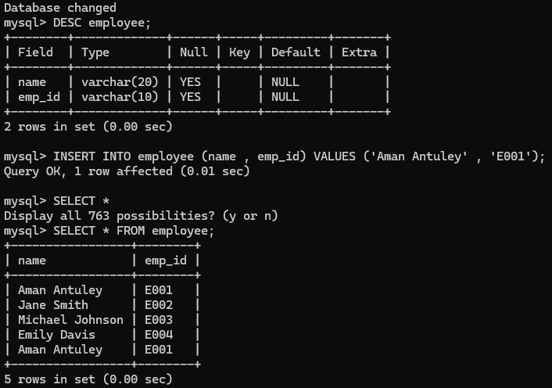

**Syntax : Update**

UPDATE *table_name*  
SET *column1*=*value1*,*column2*=*value2*, ...  
WHERE *condition*;

The WHERE clause specifies which record(s) that should be updated. If you skip the WHERE clause, all records in the table will be updated!

**Output:**

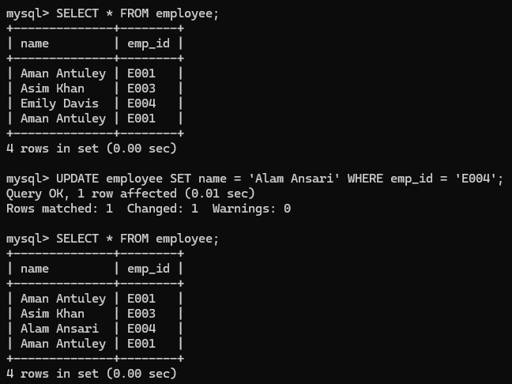

**Syntax : Delete**

DELETE FROM *table_name*WHERE *condition*;

The WHERE clause specifies which record(s) should be deleted. If you skip the WHERE clause, all records in the table will be deleted!

**Output:**



**Examples**

1. INSERT INTO employees (id, name, salary) VALUES (1, 'John Doe', 50000);
2. UPDATE employees SET salary = 60000 WHERE id = 1;
3. DELETE FROM employees WHERE id = 1;
4. SELECT * FROM employees;

**Procedure:**

1. Open the mysql software tool.
2. Practice all the above DML commands for your own case study

**Conclusion:**

Hence we have implemented the different DML commands.